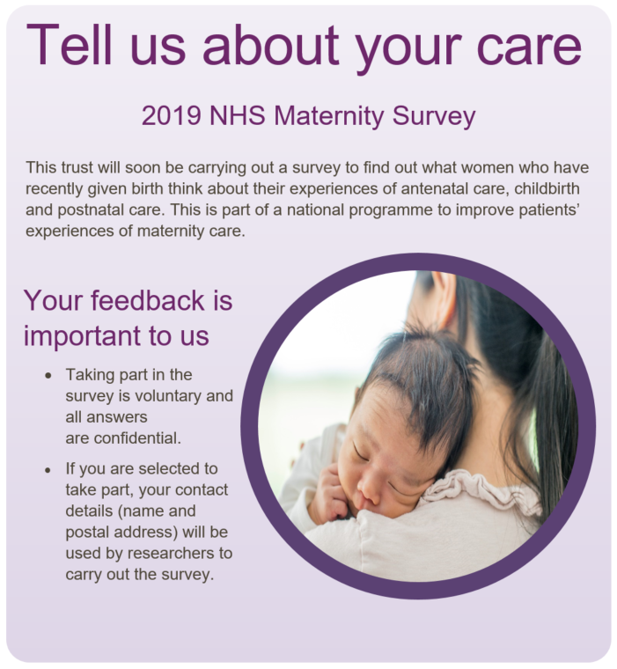
If you do not want to take part, or have any questions about the survey please contact:
[Trust phone number – this is required]

[Trust email address if available]

[Trust Address if available]

Women’s Experience of Maternity Care: 2019 Survey
What is the purpose of the survey?
It is very important for us to find out what women across England think of the maternity care they have received. Your views are important to help us find out how good maternity services are and how they can be improved. If you fill out the questionnaire, the anonymous results will be fed back to the hospital, be used in the assessment of the hospital and will feed into CQC inspections. They will also be published on our website, so that other women planning to give birth can see the results.
Why me?
You may be invited to take part in this survey in a few months’ time because you recently had a baby. We are sending questionnaires to other women who gave birth during the same period. Questionnaires will be sent out in April or May 2019.
Do I have to take part?
No. Taking part in this survey is voluntary. If you do not wish to take part it will not affect the care you receive from the NHS. If you do not wish to take part, or do not want to answer some of the questions, you do not need to give us a reason. You can return the blank questionnaire in the FREEPOST envelope or call the survey helpline number to tell us that you do not wish to take part.
If I take part, will my answers be kept confidential?
Yes. We will give you a unique number so that your name and address is not on the questionnaire, and your name and address will never be linked to your responses. We will use your anonymous responses to provide information about the quality of the services the trust provides and to help us improve these services. All personal information you provide will be destroyed within six months of you taking part in the survey.
Who is organising the survey?
The survey is being carried out by researchers from this NHS Trust (or independent contractor staff that they employ), the Care Quality Commission and the Survey Coordination Centre at Picker. The results will be presented in a form that does not allow any individual's answers to be identified.
I do not wish to take part. What do I do?
If you do not wish to take part, or for your details to be shared with researchers so you can be sent a questionnaire, or if you have any questions about the survey, then please let us know by the end of March using the contact details on the front of this leaflet.

